IMS Booking system
User guide

About this program
The program is used to manage bookings, collating all the required paperwork and data to allow council to manage clashes and approve bookings.
Table of Contents

About this program 2
Logging on 3
Update your contact details 4
Casual bookings 4
Completing an application for casual use 5
Once your application is submitted 7

Logging on
This program is cloud based and can be accessed from any computer or device with internet connection. You will need to set up an account with your unique username and password.
Tip: Save www.imscomply.com.au in your email system as “not junk” to ensure you receive these notifications.
Step 1
Cut and paste the program URL supplied into your preferred internet browser.

Step 2  Select Create account. Fill out required information and select Register. | 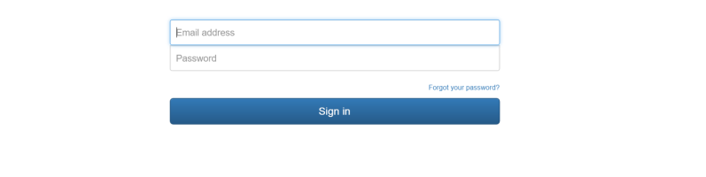
Step 3  An email will be sent to your email address. Click on the link per email to validate and activate your account. | 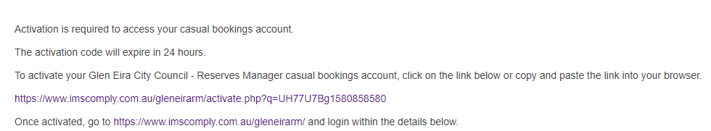
Step 4
Your email will become your username, select a password and sign in.

Update your contact details
About | How to
Update contact details  You can keep your key contact’s details up to date in this area including:  - Contact details  - Password and email | Always ensure there is a valid email address entered, so email alerts can be received and attended to. If you change your email address, your username will change to reflect this.  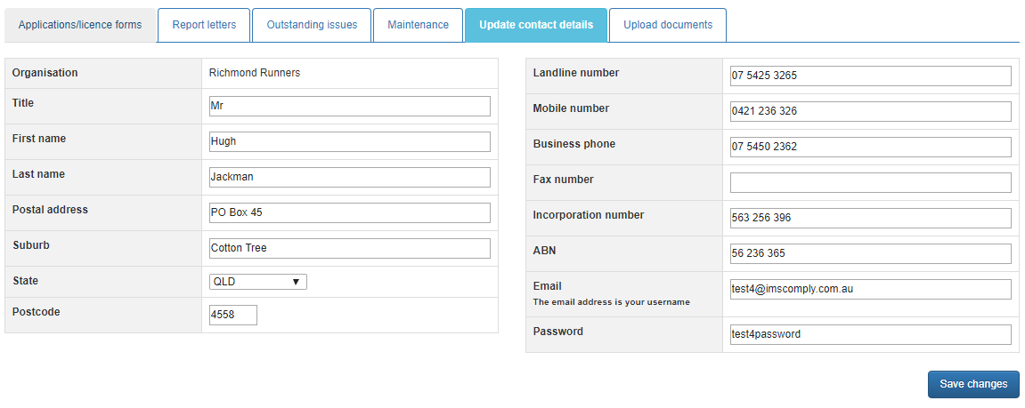  Click on save changes if any edits are made.

Casual bookings

Check availability
Before starting your application check the bookings calendar tab to ensure the venue/sports facility is available for use. Select the date and asset you require to see whether it is available to book.

Completing an application for casual use
Ensure you have selected the correct form that corresponds with the type of booking you wish to make.
About | How to
Start casual booking application  Start your application from the Applications/License form tab. | 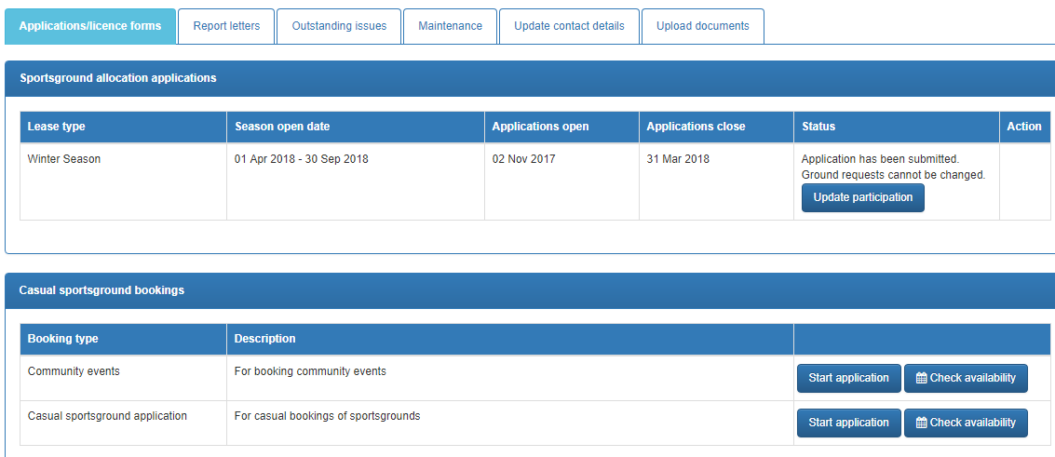  First click on check availability to see if the ground/venues you are after are booked for the date and time you need them.  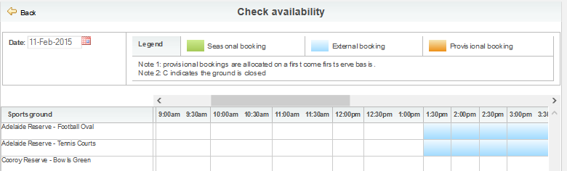  Once you have confirmed the grounds are free, click on the back key to return to start your application.
Contact details  These will populate from your contact details tab. | Check your contact details are correct.

About | How to
Booking information  Select the asset you wish to book and give the council some details about your event to allow them to assess your requirements and allocate venues, assets or sportsgrounds. | Choose a reserve/ venue and provide details on your needs.
Repeat bookings  One or multiple bookings can be made.  Tip: For recurring bookings with a holiday break in the middle it is best to make 2 separate recurring bookings, for before and after the break. | Choose the date and start and finish times for the booking. If this is a recurring booking, tick the checkbox and choose a repeat pattern and number of times or end time of the repeating occurance.  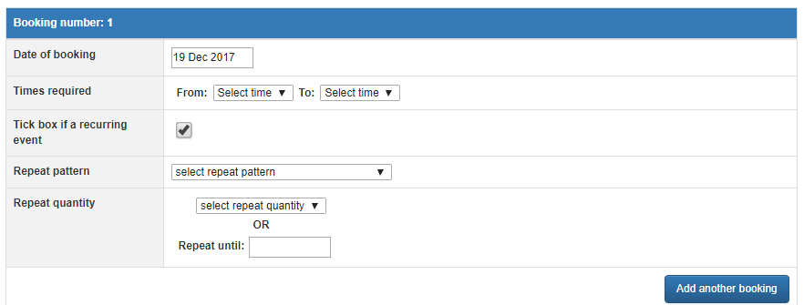  To add another booking with different times, click on Add another booking.
Public Liability Certificate  You will be required to upload this document. | Click on upload to add document to the application and enter an expiry date. You will not be asked to attached your PLI to any further casual bookings until this date has passed.  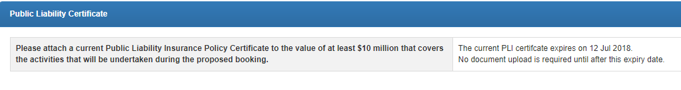
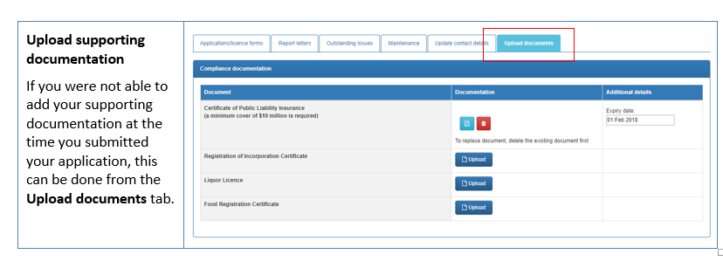
About | How to
Terms and conditions  Read terms and conditions. | Click on the T&C PDF to read. This must be opened before the applicant can submit the application.
Submit application  When all required fields have been entered and the Terms and Conditions opened and agreed to via the checkbox, the Submit Application icon will be available. | Tick the checkbox agreeing to the terms and conditions. Submit application.  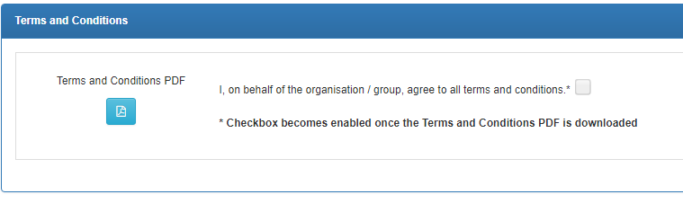  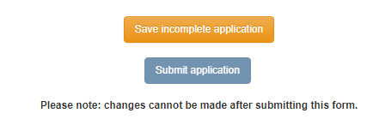
View approved applications  You can view approved casual bookings once they have been processed. | From the Applications/Licenses tab, scroll down to Submitted applcations find your approved booking or continue to complete an application. Click on the magnifying glass to view details.  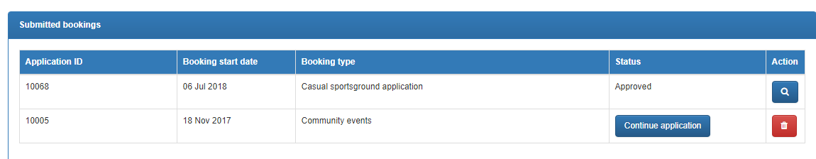  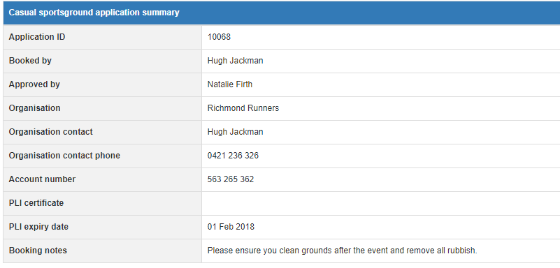

Once your application is submitted
Council will receive your application and either allocate you a booking, reset your application to make changes, or reject your booking. You will be notified by email and can view the status of your application in the License/Applications tab. An invoice will be sent for payment to secure the booking.
If you have any further queries, please contact the bookings officer on recservices@gleneira.vic.gov.au

